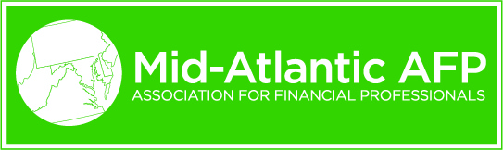

2019-2020 January Webinar – January 29, 2020, 3:00 to 4:00 PM

Registration
Payment | $0 Members / $25 Non-Members
Attendees | All members, non-members
CEU | 1.2 CTP / FP&A | Request submitted to AFP 1/22/2020
Location | Webinar
Session
Time | 3:00-4:00 PM
35-word description | Speakers will present considerations important in international banking, describe a number of foreign exchange risk management common themes, and provide an update on the current macroeconomic landscape.
Contact info | Fran Dwyer| Executive Director – Treasury Management Officer | Healthcare, Higher Education & Nonprofit Industries | Commercial Bank | J.P. Morgan | 925 Westchester Avenue, 3rd Floor, White Plains, New York, 10604 | T: 914-993-2226 | fran.dwyer@jpmorgan.com
Speaker 1
Name | Christopher Hansen | 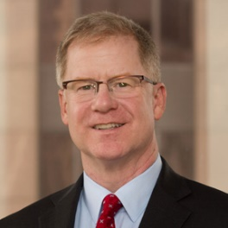
Title | Executive Director
Company | JP Morgan Chase
Bio | Christopher Hansen is an Executive Director at JP Morgan Chase in Chicago. Chris currently assists the national FX, interest rate and commodity sales team consulting on derivative accounting and structuring projects. Over a 30 year career at JP Morgan Chase and three of its predecessor banks, he has held positions managing the Foreign Exchange sales, derivatives risk management, loan workout, and industry analysis. Chris is a CPA and a CFA charter holder and received a BS in Accountancy from the University of Illinois, Champaign/Urbana.
Speaker 2
Name | Hiral Patel | 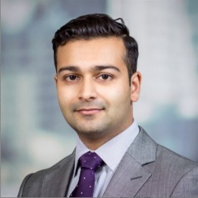
Title | Associate, FX Risk Management
Company | JP Morgan Chase
Bio | Hiral Patel is an Associate at JP Morgan Chase in New York. Hiral works with clients in the Northeast to help identify and manage their foreign exchange exposure. He holds over 9 years of experience at J.P. Morgan holding various roles in foreign exchange. Hiral received a BS in Business and Technology from Steven Institute of Technology in New Jersey.

Speaker 3
Name | Daniel Witcik | 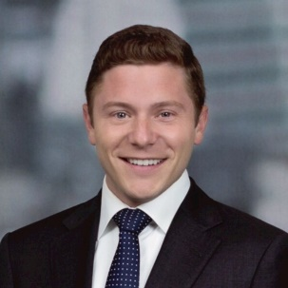
Title | Associate, Investment Banking
Company | JP Morgan Chase
Bio | In Process

