Amber Thompson, Associate Project Manager
amber.thompson@highradius.com
Amber Thompson is currently Associate Project Manager for Treasury. At HighRadius, she helps companies implement Treasury systems in multiple regions and for companies of all sizes ranging from Global 100 to small and medium size companies.
Amber has direct experience in consulting, project management, implementations and working with customers and product teams to meet the needs of clients in different markets and areas of treasury such as cash forecasting and cash management.

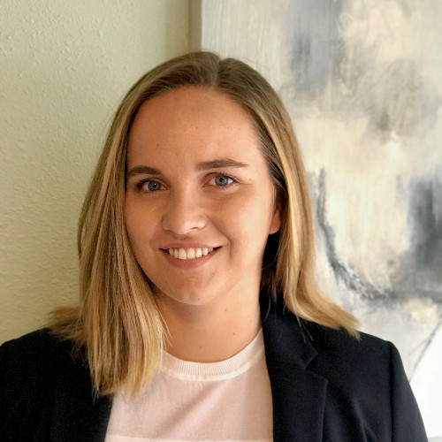
Bernice Van Der Velden, Senior Consultant
bernice.vandervelden@highradius.com
Bernice Van Der Velden consults with customers on large Treasury Management projects and helps them transform their cash forecasting and cash management operations. She has worked directly with CFO’s, Treasurers, and AR Directors from Fortune 500 to smaller sized companies. Bernice is currently working as a Senior Consultant at HighRadius where she designs and implements multiple complex solutions by working closely with treasury professionals.

