June Lunch & Learn Webinar:
“Four Pillars of Best-in-Class Cash Flow Forecasts”
June 23, 2021, 12:00 to 1:00 PM

Registration
Payment | $0 Members / $0 Non-Members
Attendees | All members, non-members
CEU | Up to 1.2 CTP / FP&A
Location | Webinar
Session
Time | 12:00-1:00 PM
Description | While there is no “silver bullet” to solve every company’s cash forecasting roadblocks, having the right processes in place is a good start. AI is bringing a new focus to cash forecasting with brand new solutions to age-old processes.  What and how you measure success will vary depending on your business, industry, and goals. It starts with a detailed self-assessment of your existing cash forecasting processes. This is essential to isolate gaps in your performance and identify opportunities for improvement. A better forecast can directly reveal potential liquidity constraints ahead so that the treasury department can proactively mitigate challenges.  The Cash Forecasting Maturity Model can help decision makers perform an in-depth evaluation of their current cash forecasting processes and identify clear next steps to become best-in class.  Join our presenters they walk attendees through the Cash Forecasting Maturity Model and build robust process areas regardless of organization size and complexity.
Main Contact info | Estefania “Stefi” Bravo Correa  Treasury Marketing Coordinator  e. stefi.bravo-correa@highradius.com  m. 832.330.4276  o. 346.395.5487
Speaker 1
Name | Bernice Van Der Velden, | 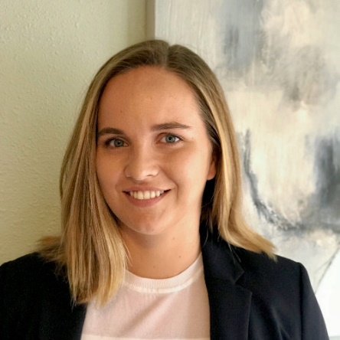
Title | Senior Consultant
Company | High Radius
Contact | bernice.vandervelden@highradius.com
Bio | Bernice Van Der Velden consults with customers on large Treasury Management projects and helps them transform their cash forecasting and cash management operations. She has worked directly with CFO’s, Treasurers, and AR Directors from Fortune 500 to smaller sized companies. Bernice is currently working as a Senior Consultant at HighRadius where she designs and implements multiple complex solutions by working closely with treasury professionals.
Speaker 2
Name | Amber Thompson
Title | Associate Project Manager
Company | High Radius
Contact | amber.thompson@highradius.com
Bio | Amber Thompson is currently Associate Project Manager for Treasury. At HighRadius, she helps companies implement Treasury systems in multiple regions and for companies of all sizes ranging from Global 100 to small and medium size companies.  Amber has direct experience in consulting, project management, implementations and working with customers and product teams to meet the needs of clients in different markets and areas of treasury such as cash forecasting and cash management.
,

